Daughters of Penelope Foundation, Inc.
2017 Scholarship Recipients
We are very grateful to the Chapters, members of the Daughters of Penelope / AHEPA and private donors who have contributed to these scholarships. Because of your past, present and future support, we are able to continue making a difference in the lives of these young women, and to many others, assisting them toward their achievement of their academic goals.
Dorothy Lillian Quincey  Memorial Graduate Scholarship |  |  | Alexandra Apostolides Sonenfeld Memorial Undergraduate Scholarship |  |  | Daughters of Penelope  Past Grand Presidents Undergraduate Scholarship
Julie Christine Rice |  |  | Irini Tsouakas |  |  | Anna Grunder
 | Clemson University  Food Technology and Packaging  $2,500.00 |  | 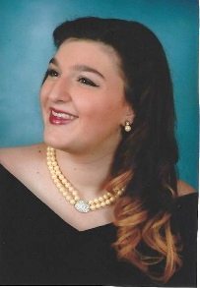 | Hofstra University  Psychology  $1,500.00 |  |  | The Ohio State University  Logistics Management  $1,500.00
Helen J. Beldecos, Past Grand President, Scholarship (Undergraduate) |  |  | Daughters of Penelope  Past Grand Presidents Memorial Scholarship (Undergraduate) |  |  | Mary M. Verges, Past Grand President, Scholarship (Undergraduate)
Kassandra Mastras |  |  | Georgia McFarland |  |  | Angeleki Zecopoulos
 | University of California,  Los Angeles  Classics  $1,500.00 |  |  | Johns Hopkins University  Math/Engineering  $1,000.00 |  |  | Clemson University  Pre-Pharmacy  $1,000.00
The Big Five Graduate  Scholarship (Undergraduate) |  |  | Sonja B. Stefanadis Graduate Student Scholarship |  |  | Joanne V. Hologgitas PhD, Past Grand President, Memorial Scholarship
Margarita Demetriadis |  |  | Marina Kosturos |  |  | Marissa Demitrion
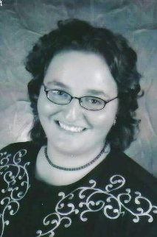 | University of  South Carolina  Library and Information Science  $1,000.00 |  |  | Arthur A. Dugoni School of Dentistry  Doctor of  Dental Surgery  $1,000.00 |  |  | University of Southern California  Anthropology  $1,000.00
Eos #1 Mother Lodge Chapter Scholarship (Undergraduate) |  |  | Paula J. Alexander Memorial Scholarship (Undergraduate) |  |  | Kottis Family Scholarship (Undergraduate)
Mary Senos |  |  | Alexis MacAskill |  |  | Nicoletta Korongy
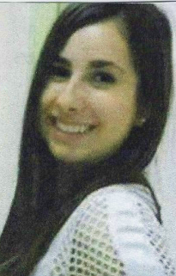 | University of Delaware  International Relations  $1,000.00 |  | 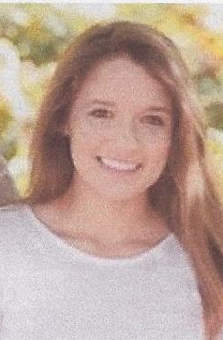 | University of Washington  Computer Science Engineering  $1,000.00 |  |  | University of Miami  Environmental Sciences  $1,000.00
Hopewell Agave Chapter #224 Scholarship (Undergraduate) |  |  | Barbara Edith Quincey Thorndyke Memorial Undergraduate Scholarship |  |  | Mary Kandaras Memorial Scholarship
Cassandra Likouris |  |  | Erica Pantelatos |  |  | Christina Manos
 | Kent State  University  Political Science  $1,000.00 |  |  | Wright State University  Nursing  $1,000.00 |  | 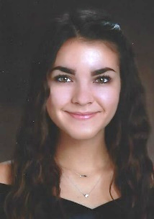 | Georgia Institute of Technology  Chemistry  $1,000.00
The Sotiri Zervoulias &  Lea Soupata Scholarship |  |  | Clara R. Payne Memorial Scholarship |  |  | Daughters of Penelope Undergraduate Scholarship
Tracy Mauricette |  |  | Elena Zoe Dennie |  |  | Alexandra Sangermano
 | Dutchess Community College  Criminal Justice  $500.00 |  |  | University College London  Anthropology  $1,000.00 |  |  | University of  Rhode Island  Marine Biology  $1,000.00
Daughters of Penelope Undergraduate Scholarship |  |  | Daughters of Penelope Undergraduate Scholarship |  |  | Daughters of Penelope Undergraduate Scholarship
Alyssa Eliopulos |  |  | Megan Sullivan |  |  | Nicole Tank
 | Washington State  University  Pre-Medicine  $1,000.00 |  |  | Texas A&M University  Psychology and Community Health Science  $1,000.00 |  | 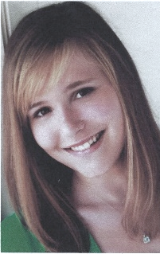 | University of Nebraska-Lincoln  Veterinary Science  $1,000.00
Daughters of Penelope Undergraduate Scholarship |  |  | Daughters of Penelope Undergraduate Scholarship |  |  | Daughters of Penelope Undergraduate Scholarship
Sophia Chryssofos |  |  | Stephanie Nash |  |  | Victoria Trakas
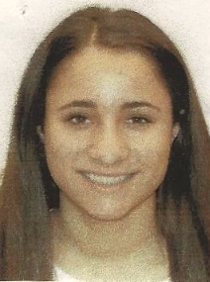 | Boston College  Biology  $1,000.00 |  | 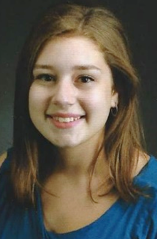 | Loyola University Chicago  Engineering  $1,000.00 |  |  | 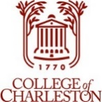  College of Charleston  Arts Management  $1,000.00
Applications for next year’s scholarships will be available online on the foundation’s website at www.dopfoundationinc.com and on the Daughters of Penelope website at www.daughtersofpenelope.org in January 2018.

