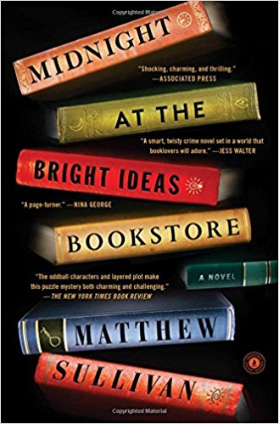

Discussion Questions

1. How is Lydia’s relationship with the past presented? How does it evolve over the course of the novel?

2. Lydia’s familiarity with books is crucial to the plot. It seems she lives her life hiding in plain sight among books. Discuss this aspect of her character.

3. Discuss the significance of Joey’s cutouts in books as a means of communication.

4. The writer weaves a tight web of a story with characters whose lives are intertwined yet they all feel lonely and isolated. Explore these themes with your group. What are some other themes you see?

5. What were your initial impressions of Lydia’s father? How did your impressions change over the course of the novel? Did you think that her father was guilty?

6. Using the quote below as a starting point, discuss Lydia’s drive to uncover the mystery:

“But then not having answers had always been the point: the point of her childhood, the product of her hours in the library, the sum of [her father’s] philosophy when she was a little girl. You leave yourself open to answers, he’d always taught her. You keep turning pages, you finish chapters, you find the next book. You seek and you seek and you seek, and no matter how tough things become, you never settle”.

7. Once Lydia discovers that David has been communicating with her father and knows about the night of the murders, she feels betrayed. Did you imagine they would recover from the secrecy?

8. Did Mrs. Patel’s final act take you by surprise? How did it resonate with you?

9. At what point did you solve the mystery of who had committed the murder?

10. Where does the writer leaves us with Lydia and her relationship to the murders and to herself?

