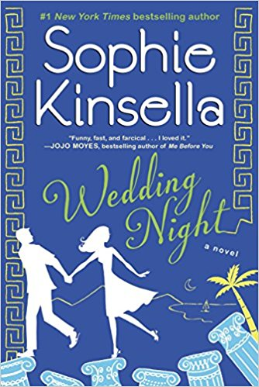

Discussion Questions

1. Why is Fliss worried about Lottie when Richard fails to pop the question? Is Fliss overprotective of Lottie?
2. Why does Lottie accept Ben's proposal?

3. Fliss plans to sabotage the marriage. Is she overreacting? Does Lottie's history of "Unfortunate Choices" justify the risks Fliss is taking?

4. What memories does Lottie have of Ben and their adventures on a Greek island? How does Lottie feel about being back there again? Has it changed?

5. Why does Noah make up stories? Does he have a big imagination or is something else the reason?

6. One theme of this novel is the sister relationship. What other themes did you note?

7. What does Lorcan think of Ben and Lottie's marriage? Does his opinion change?

8. What makes Lottie realize the marriage was a mistake?

9. Did you enjoy the book's style of alternating points of view between Lottie and Fliss?

10. What finally brings Fliss closure and begins to heal her wounded spirit?

11. Choose one of the characters and discuss how the trip to Greece changed him/her.

12. This book is a light beach read but underneath there are also some deep messages. Do you agree?

