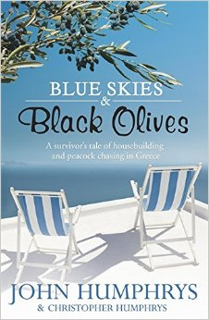

Discussion Questions

1. What attracts the writer to Greece? Why does he fall in love with the country?
2. Did you like the book's co-authored writing style with the change of voice between John and Christopher? Did you prefer the point of view of the father or the son?
3. Were you immersed in the catalogue of incidents encountered as the writer tried to get his dream house built in Greece? Which incident resonated the most with you?
4. Discuss the observations made in the book of cultural differences between the Greeks and the British.
5. The book provides readers with a very detailed description of the complicated Greek bureaucracy. Would you build a house in Greece when you are faced with such bureaucracy?
6. Compare John's experience as a farmer in Wales and in Greece? Did you note similarities?
7. Would you say that Christopher is a better adjusted and culturally more sensitive person than John?
8. How did you like the episode about the peacock? Did it fit in with the rest of the book?
9. Were you surprised by the experiences with the Greek medical and legal systems as described in the book? What surprised you?
10. Are you left with the impression that everything they went through was worth it in the end?

