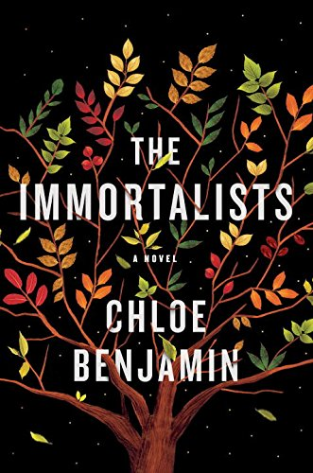

Discussion Questions

1. The book explores the degree to which we shape our own destinies — do you believe that the siblings’ fate was preordained? Why or why not?
2. The novel takes place in very different settings — 1960s New York City, the San Francisco dance scene, glitzy Las Vegas hotels. In what ways do these locations affect the characters? Why do you think all the siblings moved away from New York City?
3. The Immortalists is the story the four siblings told in separate sections. What was your reading experience as you switched sections?
4. The power of belief is an important theme in the novel. How does belief affect each of the siblings? What is different or similar about the stories they tell themselves?
5. At its heart, this book is a family love story, exploring both past and future generations of the Gold family. In what ways does family history shape us? What kind of legacies do the four siblings leave behind?
6. How do magic and reality blur in the novel? Were there any particular moments that seemed to defy logic? Why are certain characters drawn to magic and the unknowable more than others?
7. Discuss the siblings’ significant others: Raj, Mira and Robert. How are their lives affected by the prophecy? How do romantic and familial relationships interact and contrast in the book?
8. At the end of the novel, Gertie tells Varya about the beauty and freedom in uncertainty, questioning why her children believed the fortune teller. Did you believe the fortune teller? What gives the fortune teller her power? What freedoms does uncertainty bring?
9. What do you imagine happens to Varya after the book ’s ending? How have her views on longevity and death changed?
10. How did the characters live their lives differently because of this information?

