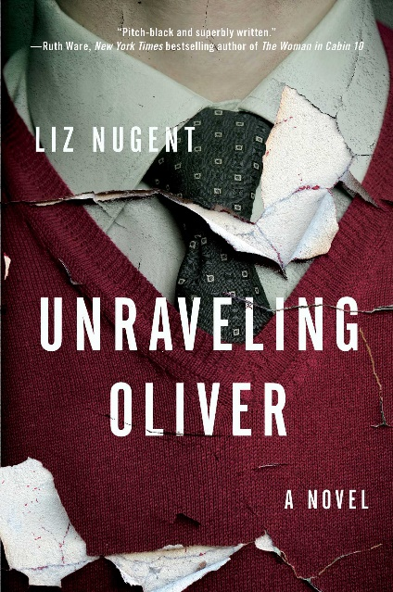

Discussion Questions

- Is Oliver a reliable narrator? Do you trust him more or less as you learn more about him as the story progresses? Why?

- What does Oliver fail to learn in his childhood about treating women?

- How do the narrators bring Oliver's character into focus? Which narrator would you have liked to hear more from?

- Whose story is missing from the narrators? What do you think he or she would say about Oliver?

- Why does Oliver not want children? Does his reason change over time?

- Does Oliver understand how to be a father? Why or why not?

- Why do Oliver and Laura break up? What role did the events of the summer in France play in their relationship?

- Why does Oliver marry Alice? How might things have turned out differently for Alice had she not gone to a Greek island with Oliver? Would they have still ended up together?

- Did Oliver love Laura? Did he love Alice? Compare the two relationships.

- To what lengths will Oliver go in order to protect his secrets? Does Oliver take responsibility for his actions?

